Patterned Paper Control - Monkeys

Zeynep Civelek

June 30, 2020

## Exploring data

The structure of the data is shown below with all the variable names and levels of measurement.

## 'data.frame': 448 obs. of 11 variables:  
## $ id : Factor w/ 14 levels "Alba","Bear",..: 11 11 11 11 11 11 11 11 11 11 ...  
## $ sex : Factor w/ 2 levels "f","m": 2 2 2 2 2 2 2 2 2 2 ...  
## $ age : int 8 8 8 8 8 8 8 8 8 8 ...  
## $ order : Factor w/ 2 levels "foodfirst","stickfirst": 1 1 1 1 1 1 1 1 1 1 ...  
## $ boxtype : Factor w/ 2 levels "blue","pink": 1 1 1 1 1 1 1 1 1 1 ...  
## $ phase : Factor w/ 2 levels "pattern-test",..: 1 1 1 1 1 1 1 1 1 1 ...  
## $ sessionno: int 1 1 1 1 1 1 1 1 2 2 ...  
## $ trialno : int 1 2 3 4 5 6 7 8 9 10 ...  
## $ correct : int 1 1 1 1 1 1 1 1 0 1 ...  
## $ trialtype: Factor w/ 2 levels "food","stick": 1 1 1 1 1 1 1 1 1 1 ...  
## $ phase2 : Factor w/ 2 levels "1","2": 1 1 1 1 1 1 1 1 1 1 ...

Exploring the warm-up 1 (the cups are initially empty/not covered and after the hiding event the baited cup is covered with patterned paper and the empty cup is covered with white paper) and warm-up 2 phases (the cups are initially covered with white paper and after the hiding event, the baited cup is covered with patterned paper).

## [1] 1 11

## [1] 1 2

**In warm-up 1, monkeys received up to 11 sessions to reach criterion and in warm-up 2, up to 2 sessions (or they'd receive up to 10 sessions). The minimum number of sessions to reach criterion was 2 (14/16 correct)**

## Histograms for Warm-up 1 and Warm-up 2 Phases

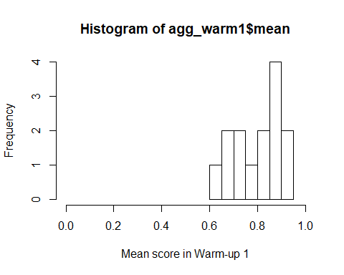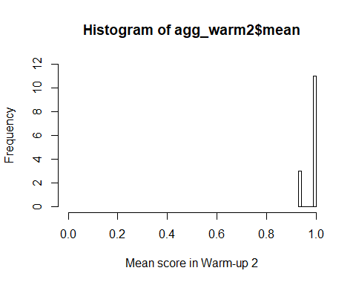 **The data shows that after the initial warm up phase, the monkeys very quickly learnt to find the reward in the patterned cup.**

I then aggregated the trial-by-trial data to create one score per monkey for Test and Transfer phases so I can check whether or not they are normally distributed.

## Histograms for Test and Transfer Phases and the overall score

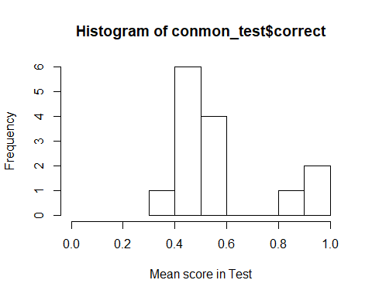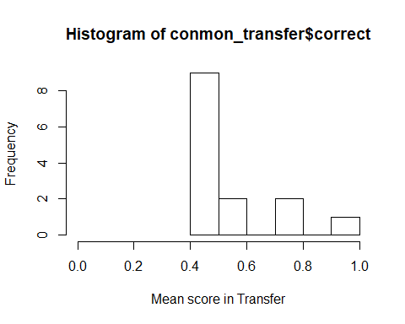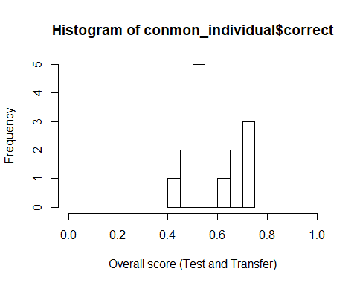 ##The tests of normality for Test and Transfer phases as well as for the overall score

##   
## Shapiro-Wilk normality test  
##   
## data: conmon_individual$correct  
## W = 0.88264, p-value = 0.06338

##   
## Shapiro-Wilk normality test  
##   
## data: conmon_test$correct  
## W = 0.74892, p-value = 0.001246

##   
## Shapiro-Wilk normality test  
##   
## data: conmon_transfer$correct  
## W = 0.74102, p-value = 0.001017

The Shapiro-Wilk normality tests show that the data are not normally distributed for Test and Transfer phases but it is normal for the overall scores per individual.

## Below is how performance looks in the last 16 trials of Test and Transfer

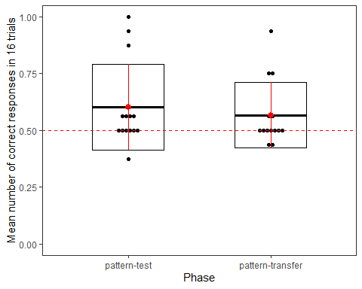

## Preparation of the data for running the GLMM

* Scaling age and trial number
* Coding categorical variables (trial type, sex, phase) as dummy variables
* Centering the slopes.

## Full model

contr<-glmerControl(optimizer="bobyqa", optCtrl=list(maxfun=10000000))  
full=glmer(correct ~ trialtype*phase+z.trialno+z.age+sex+(1+z.trialno+phase.transfer.c+trialtype.food.c|id),data=conmon1, family=binomial, control=contr)

The full model does not include box type (the location of the blue/pink box) as a random effect anymore due to convergence issues. There is the singular fit warning here and throughout though.

## Model assumptions

#### Distribution of random effects

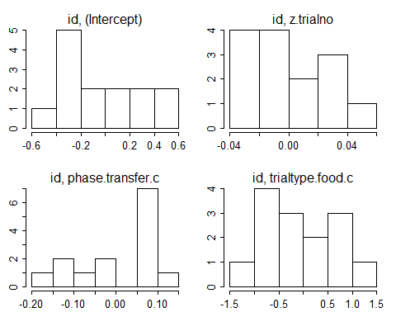

#### Model stability

## [1] "please carefully evaluate whether the result makes sense, and if not, please contact me"

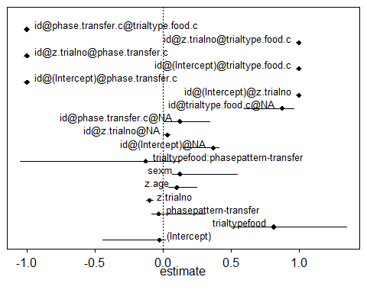

## what  
## (Intercept) (Intercept)  
## trialtypefood trialtypefood  
## phasepattern-transfer phasepattern-transfer  
## z.trialno z.trialno  
## z.age z.age  
## sexm sexm  
## trialtypefood:phasepattern-transfer trialtypefood:phasepattern-transfer  
## id@(Intercept)@NA id@(Intercept)@NA  
## id@z.trialno@NA id@z.trialno@NA  
## id@phase.transfer.c@NA id@phase.transfer.c@NA  
## id@trialtype.food.c@NA id@trialtype.food.c@NA  
## id@(Intercept)@z.trialno id@(Intercept)@z.trialno  
## id@(Intercept)@phase.transfer.c id@(Intercept)@phase.transfer.c  
## id@(Intercept)@trialtype.food.c id@(Intercept)@trialtype.food.c  
## id@z.trialno@phase.transfer.c id@z.trialno@phase.transfer.c  
## id@z.trialno@trialtype.food.c id@z.trialno@trialtype.food.c  
## id@phase.transfer.c@trialtype.food.c id@phase.transfer.c@trialtype.food.c  
## orig min max  
## (Intercept) -0.02582626 -0.445188429 0.01791560  
## trialtypefood 0.81408346 0.502150660 1.34976686  
## phasepattern-transfer -0.03202943 -0.083478598 0.30981133  
## z.trialno -0.09828372 -0.122677518 -0.07382107  
## z.age 0.10243656 0.042376812 0.24970230  
## sexm 0.12507136 0.066579185 0.54739966  
## trialtypefood:phasepattern-transfer -0.12764870 -1.049911977 0.12427047  
## id@(Intercept)@NA 0.37007839 0.148495839 0.41278183  
## id@z.trialno@NA 0.03392926 0.002254978 0.05399376  
## id@phase.transfer.c@NA 0.12501023 0.004640399 0.34283920  
## id@trialtype.food.c@NA 0.87628447 0.596647568 0.96230125  
## id@(Intercept)@z.trialno 1.00000000 1.000000000 1.00000000  
## id@(Intercept)@phase.transfer.c -1.00000000 -1.000000000 -1.00000000  
## id@(Intercept)@trialtype.food.c 1.00000000 1.000000000 1.00000000  
## id@z.trialno@phase.transfer.c -1.00000000 -1.000000000 -1.00000000  
## id@z.trialno@trialtype.food.c 1.00000000 1.000000000 1.00000000  
## id@phase.transfer.c@trialtype.food.c -1.00000000 -1.000000000 -1.00000000

## [1] none none none none none none none none none none none none none none  
## Levels: none

#### Multicollinearity

## trialtype phase z.trialno z.age sex   
## 2.407 2.407 1.000 1.201 1.144   
## trialtype:phase   
## 3.733

#### Overdispersion

## chisq df P dispersion.parameter  
## 1 416.5265 431 0.6828999 0.9664189

## Null model

null=glmer(correct~(1+z.trialno+phase.transfer.c+trialtype.food.c|id),data=conmon1, family=binomial, control=contr)

**Question: I do have (1|id) as another random effect in the child model. Do I not need to include it here?**

## Full and Null comparison

## Data: conmon1  
## Models:  
## null: correct ~ (1 + z.trialno + phase.transfer.c + trialtype.food.c |   
## null: id)  
## full: correct ~ trialtype * phase + z.trialno + z.age + sex + (1 +   
## full: z.trialno + phase.transfer.c + trialtype.food.c | id)  
## npar AIC BIC logLik deviance Chisq Df Pr(>Chisq)  
## null 11 610.29 655.44 -294.14 588.29   
## full 17 615.46 685.25 -290.73 581.46 6.824 6 0.337

## Model output

#### Coefficients

## Estimate Std. Error z value Pr(>|z|)  
## (Intercept) -0.026 0.327 -0.079 0.937  
## trialtypefood 0.814 0.459 1.774 0.076  
## phasepattern-transfer -0.032 0.320 -0.100 0.920  
## z.trialno -0.098 0.102 -0.968 0.333  
## z.age 0.102 0.143 0.717 0.474  
## sexm 0.125 0.278 0.451 0.652  
## trialtypefood:phasepattern-transfer -0.128 0.666 -0.192 0.848

#### Individual predictor: Likelihood tests

## Single term deletions  
##   
## Model:  
## correct ~ trialtype * phase + z.trialno + z.age + sex + (1 +   
## z.trialno + phase.transfer.c + trialtype.food.c | id)  
## npar AIC LRT Pr(Chi)   
## <none> 615.46   
## z.trialno 1 620.37 6.908 0.009 **  
## z.age 1 613.95 0.481 0.488   
## sex 1 613.66 0.196 0.658   
## trialtype:phase 1 613.50 0.036 0.849   
## ---  
## Signif. codes: 0 '***' 0.001 '**' 0.01 '*' 0.05 '.' 0.1 ' ' 1

#### Confidence intervals for the full model with the interaction

## orig X2.5. X97.5.  
## (Intercept) -0.026 -0.700 0.674  
## trialtypefood 0.814 -0.028 1.836  
## phasepattern-transfer -0.032 -0.727 0.654  
## z.trialno -0.098 -0.310 0.104  
## z.age 0.102 -0.184 0.431  
## sexm 0.125 -0.442 0.700  
## trialtypefood:phasepattern-transfer -0.128 -1.550 1.035

**The null and full models are not significantly different from each other. But the interaction term is not significant. I will remove this next to see if it improves the model.**

## Reduced model without the interaction

## Full model 2

full2=glmer(correct ~ trialtype+phase+z.trialno+z.age+sex+(1+z.trialno+phase.transfer.c+trialtype.food.c|id),data=conmon1, family=binomial, control=contr)  
summary(full2)

## Generalized linear mixed model fit by maximum likelihood (Laplace  
## Approximation) [glmerMod]  
## Family: binomial ( logit )  
## Formula: correct ~ trialtype + phase + z.trialno + z.age + sex + (1 +   
## z.trialno + phase.transfer.c + trialtype.food.c | id)  
## Data: conmon1  
## Control: contr  
##   
## AIC BIC logLik deviance df.resid   
## 613.5 679.2 -290.8 581.5 432   
##   
## Scaled residuals:   
## Min 1Q Median 3Q Max   
## -2.5261 -1.0148 0.4243 0.9176 1.1409   
##   
## Random effects:  
## Groups Name Variance Std.Dev. Corr   
## id (Intercept) 0.142735 0.3778   
## z.trialno 0.001156 0.0340 1.00   
## phase.transfer.c 0.013867 0.1178 -1.00 -1.00   
## trialtype.food.c 0.778012 0.8820 1.00 1.00 -1.00  
## Number of obs: 448, groups: id, 14  
##   
## Fixed effects:  
## Estimate Std. Error z value Pr(>|z|)   
## (Intercept) 0.008027 0.275245 0.029 0.9767   
## trialtypefood 0.751037 0.318487 2.358 0.0184 *  
## phasepattern-transfer -0.065151 0.268487 -0.243 0.8083   
## z.trialno -0.098297 0.101599 -0.967 0.3333   
## z.age 0.091223 0.130733 0.698 0.4853   
## sexm 0.104556 0.257140 0.407 0.6843   
## ---  
## Signif. codes: 0 '***' 0.001 '**' 0.01 '*' 0.05 '.' 0.1 ' ' 1  
##   
## Correlation of Fixed Effects:  
## (Intr) trltyp phspt- z.trln z.age   
## trialtypefd -0.233   
## phspttrn-tr -0.649 -0.029   
## z.trialno -0.002 0.059 -0.007   
## z.age -0.178 -0.026 0.266 0.004   
## sexm -0.703 -0.014 0.212 -0.002 0.077  
## convergence code: 0  
## boundary (singular) fit: see ?isSingular

I get the following warning: convergence code: 0, boundary (singular) fit: see ?isSingular.

**The model shows a significant effect of trial type**

## Null model 2

null2<-glmer(correct~ (1+z.trialno+phase.transfer.c+trialtype.food.c|id),data=conmon1, family=binomial, control=contr)

## Full and null model (2) comparion

## Data: conmon1  
## Models:  
## null: correct ~ (1 + z.trialno + phase.transfer.c + trialtype.food.c |   
## null: id)  
## full2: correct ~ trialtype + phase + z.trialno + z.age + sex + (1 +   
## full2: z.trialno + phase.transfer.c + trialtype.food.c | id)  
## npar AIC BIC logLik deviance Chisq Df Pr(>Chisq)  
## null 11 610.29 655.44 -294.14 588.29   
## full2 16 613.50 679.18 -290.75 581.50 6.788 5 0.237

## Model output

#### Coefficients

## Estimate Std. Error z value Pr(>|z|)  
## (Intercept) 0.008 0.275 0.029 0.977  
## trialtypefood 0.751 0.318 2.358 0.018  
## phasepattern-transfer -0.065 0.268 -0.243 0.808  
## z.trialno -0.098 0.102 -0.967 0.333  
## z.age 0.091 0.131 0.698 0.485  
## sexm 0.105 0.257 0.407 0.684

#### Individual predictors : Likelihood ratio tests

## Single term deletions  
##   
## Model:  
## correct ~ trialtype + phase + z.trialno + z.age + sex + (1 +   
## z.trialno + phase.transfer.c + trialtype.food.c | id)  
## npar AIC LRT Pr(Chi)   
## <none> 613.50   
## trialtype 1 616.50 5.004 0.025 *  
## phase 1 611.56 0.059 0.809   
## z.trialno 1 612.42 0.924 0.337   
## z.age 1 611.95 0.454 0.501   
## sex 1 611.66 0.160 0.689   
## ---  
## Signif. codes: 0 '***' 0.001 '**' 0.01 '*' 0.05 '.' 0.1 ' ' 1

**The model without the interaction is not significantly different from the null model either.** **Question: Since the model is not a good fit to the data, I cannot talk about the significant effect of trial type here, is this correct?**

#### Confidence intervals for the reduced model without the interaction

## orig X2.5. X97.5.  
## (Intercept) 0.008 -0.529 0.582  
## trialtypefood 0.751 0.142 1.393  
## phasepattern-transfer -0.065 -0.650 0.494  
## z.trialno -0.098 -0.313 0.097  
## z.age 0.091 -0.161 0.353  
## sexm 0.105 -0.404 0.617

## Tests against chance

#### Test and transfer phases

## T.plus N P  
## 1 31 8 0.09375

## [1] 0.53

## T.plus N P  
## 1 23 7 0.171875

## [1] 0.5

**Neither test nor transfer performances are different from chance. Any idea why I get wrong sample sizes here?**

## Mann-Whitney U-Test

##   
## Exact Wilcoxon rank sum test  
##   
## data: conmon_separate$correct by conmon_separate$phase  
## W = 113.5, p-value = 0.4655  
## alternative hypothesis: true mu is not equal to 0

## [1] 82.5

## pattern-test   
## 14

## pattern-transfer   
## 14

**There is no signficiant difference between the test and transfer performances either.**

## Plotting the findings

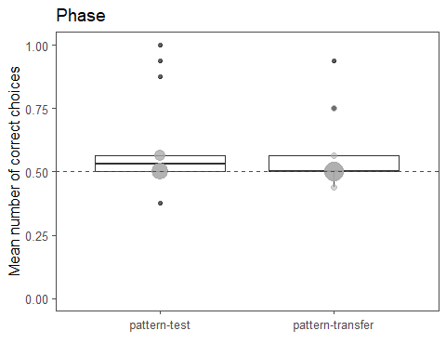

## First trial performance in Transfer phase

#### Is the performance above chance in first trial of Transfer?

##   
## One Sample t-test  
##   
## data: conmon_1st_trial$correct  
## t = -1.075, df = 13, p-value = 0.3019  
## alternative hypothesis: true mean is not equal to 0.5  
## 95 percent confidence interval:  
## 0.07004205 0.64424366  
## sample estimates:  
## mean of x   
## 0.3571429

**No, performance in the first trial of transfer does not differ from chance level.**

## Bar graph

